Odd Semester (2021)



**BINUS UNIVERSITY**

**BINUS INTERNATIONAL**

**Assignment Cover Letter**

**(Individual Work****)**

|  |  |  |  |  |  |  |  |  |
| --- | --- | --- | --- | --- | --- | --- | --- | --- |
|  | | | | |  | |  | |
| **Student Information**: **Surname** | | | | | **Given Names**  **Edbert Hans** | | **Student ID Number**  **2010684494** | |
| 1. | | **Teddyatmaja** |  | |
|  |  |
| **Course Code** | **: COMP6335** |  |  | | **Course Name** | | **: Introduction to Programming** | |
| **Class** | **: L1AC** |  |  | | **Name of Lecturer(s)** | | **:** 1. Bagus Kerthyayana | |
|  |  |  |  | |  | | 2. Tri Asih Budiono | |
| **Major** | **: CS** |  |  | |  | |  | |
| **Title of Assignment** | : Pokemon Story Game | |  |  | |  | |  | |
| **Type of Assignment**    **Submission Pattern** | **: Final Project** |  |  | |  | |  | |
| **Due Date** | **: 7-11-2016** |  |  | | **Submission Date** | | **: 7-11-2016** | |

The assignment should meet the below requirements.

1. Assignment (hard copy) is required to be submitted on clean paper, and (soft copy) as per lecturer’s instructions.
2. Soft copy assignment also requires the signed (hardcopy) submission of this form, which automatically validates the softcopy submission.
3. The above information is complete and legible.
4. Compiled pages are firmly stapled.
5. Assignment has been copied (soft copy and hard copy) for each student ahead of the submission.

# Plagiarism/Cheating

BiNus International seriously regards all forms of plagiarism, cheating and collusion as academic offenses which may result in severe penalties, including loss/drop of marks, course/class discontinuity and other possible penalties executed by the university. Please refer to the related course syllabus for further information.

# Declaration of Originality

By signing this assignment, I understand, accept and consent to BiNus International terms and policy on plagiarism. Herewith I declare that the work contained in this assignment is my own work and has not been submitted for the use of assessment in another course or class, except where this has been notified and accepted in advance.

Signature of Student: (Name of Student)

1. Edbert Hans Teddyatmaja

**“Pokemon Story Game”**

**Name :Edbert Hans Teddyatmaja**

**ID :2010684494**

1. **Description**

**Description of this program:**

This program is made based on pokemon’s original story. This program is a story game with an addition maze game inside. It is first based on the original story of pokemon and is continued with some made up stories itself. This game is only for fun purposes.

**II.**

**a. Design/Plan**

**Flowchart**

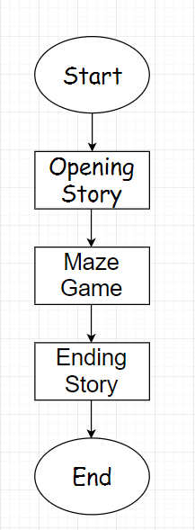

**II.**

**b. Explanation of Each function**

**Opening screen : (Op_Screen.py)**

1. **The screen is first filled with white screen in the looping process.**

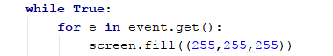

1. **Then I drew the sprites that I made in some classes. It has to be grouped first in a variable after naming the classes.**

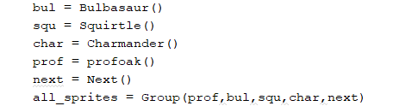

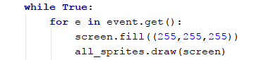

**Example for one of the sprite:**

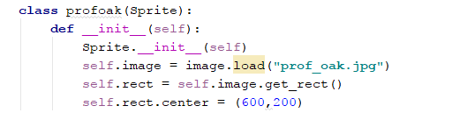

1. **Then I drew the cursor that I want by making a class of the picture of the cursor that I wanted and setting the mouse invisible. The cursor must get the actual position of the mouse and getting updates every time it is getting the actual mouse’s position.**

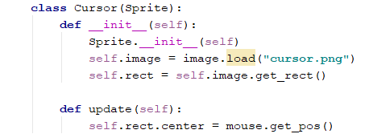

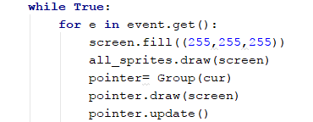

1. **I included a “next” button in the sprites that I drew earlier on the screen. Then I made a function which works if I click the sprite it will add a value in a variable outside the loop that I made before the loop. So as long the value doesn’t match the condition it won’t run the next story.**



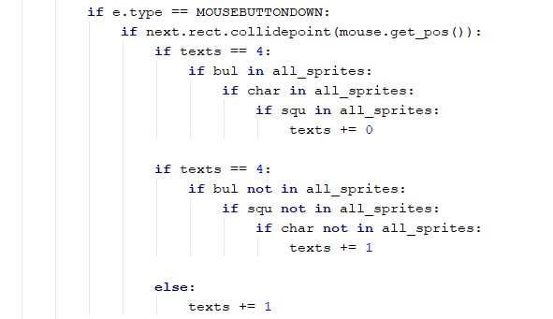

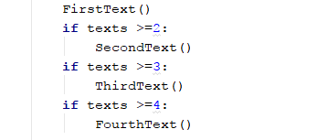

1. **In the end of the story, u will be redirected to the next story that is the maze game. You will first have to import the maze game in another file since the maze game I made is in another file.**

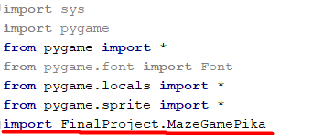

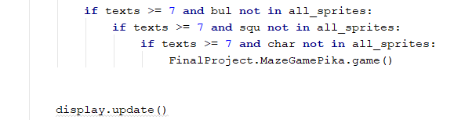

**Maze Game : ( *MazeGamePika.py* )**

1. **First, the mainscreen has to be made in a class and will be called first in the loop later on**

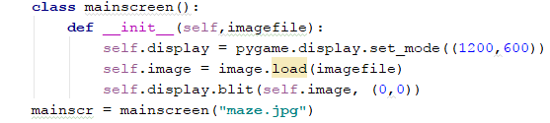



1. **Then, I have to make sprites to be the object which will cover up the spaces for the moving sprite not to move freely. Then I will have to cover these sprites again with the main screen again and display the objects that is visible during the game by drawing in the screen once again.**

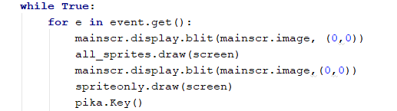

1. **Then I need to make some functions which will be the function if the moving sprite collides with other sprites.**

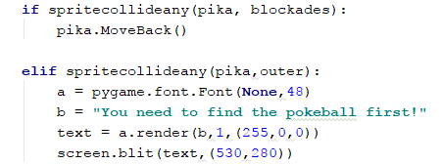

1. **If u have finished the objective, u will be redirected to the ending screen that is in another file.**

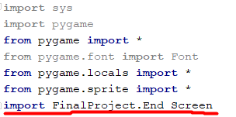

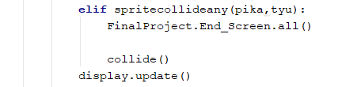

**Ending Screen: (End_Screen.py)**

1. **Same as the opening screen, we will fill the screen with white screen again and draw the sprites once again**

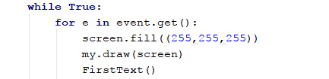

1. **Then we make some if statements saying that if next is clicked the story will continue**

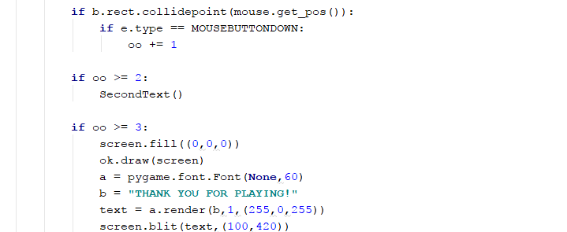

1. **Then the game ends**

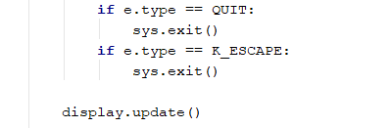

**Main Program : (Final Project.py)**

1. **This is the main program of the Game that I made**

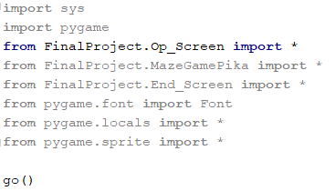

**Op_Screen.py**

**import** sys  
**import** pygame  
**from** pygame **import** *  
**from** pygame.font **import** Font  
**from** pygame.locals **import** *  
**from** pygame.sprite **import** *  
**import** FinalProject.MazeGamePika  
  
**def** go():  
 pygame.init()  
 pygame.mixer.music.load(**"cianwood.mp3"**)  
 screen = display.set_mode((1200,600))  
 display.set_caption(**"Pokemon Mini Story"**)  
  
 **class** profoak(Sprite):  
 **def** __init__(self):  
 Sprite.__init__(self)  
 self.image = image.load(**"prof_oak.jpg"**)  
 self.rect = self.image.get_rect()  
 self.rect.center = (600,200)  
  
 **class** Next(Sprite):  
 **def** __init__(self):  
 Sprite.__init__(self)  
 self.image = image.load(**"next.png"**)  
 self.rect = self.image.get_rect()  
 self.rect.center = (1100,100)  
  
 **def** FirstText():  
 a = pygame.font.Font(**None**, 24)  
 b = **"Welcome players! My name is Oak!"** c = **"You can pick one from these three choices!"** d = **"Now, go and pick one then!"** f = **"It will be your first day picking a pokemon huh?"** text = a.render(b , 1, (0,0,0))  
 screen.blit(text,(100,100))  
  
 **def** SecondText():  
 a = pygame.font.Font(**None**, 24)  
 b = **"Welcome players! My name is Oak!"** c = **"You can pick one from these three choices!"** d = **"Now, go and pick one then!"** f = **"It will be your first day picking a pokemon huh?"** text = a.render(b , 1, (0,0,0))  
 screen.blit(text,(100,100))  
 text = a.render(f,1,(0,0,0))  
 screen.blit(text, (100,120))  
  
 **def** ThirdText():  
 a = pygame.font.Font(**None**, 24)  
 b = **"Welcome players! My name is Oak!"** c = **"You can pick one from these three choices!"** d = **"Now, go and pick one then!"** f = **"It will be your first day picking a pokemon huh?"** text = a.render(b , 1, (0,0,0))  
 screen.blit(text,(100,100))  
 text = a.render(f,1,(0,0,0))  
 screen.blit(text, (100,120))  
 text = a.render(c,1,(0,0,0))  
 screen.blit(text, (100,140))  
  
 **def** FourthText():  
 a = pygame.font.Font(**None**, 24)  
 b = **"Welcome players! My name is Oak!"** c = **"You can pick one from these three choices!"** d = **"Now, go and pick one then!"** f = **"It will be your first day picking a pokemon huh?"** text = a.render(b , 1, (0,0,0))  
 screen.blit(text,(100,100))  
 text = a.render(f,1,(0,0,0))  
 screen.blit(text, (100,120))  
 text = a.render(c,1,(0,0,0))  
 screen.blit(text, (100,140))  
 text = a.render(d,1,(0,0,0))  
 screen.blit(text,(100,160))  
  
 **def** FifthText():  
 a = pygame.font.Font(**None**, 24)  
 b = **"Welcome players! My name is Oak!"** c = **"You can pick one from these three choices!"** d = **"Now, go and pick one then!"** f = **"It will be your first day picking a pokemon huh?"** g = **"Seems like all the pokemons have been taken by someone else!"** h = **"Oh wait! I have one more pokemon available here!"** text = a.render(b , 1, (0,0,0))  
 screen.blit(text,(100,100))  
 text = a.render(f,1,(0,0,0))  
 screen.blit(text, (100,120))  
 text = a.render(c,1,(0,0,0))  
 screen.blit(text, (100,140))  
 text = a.render(d,1,(0,0,0))  
 screen.blit(text,(100,160))  
 text = a.render(g,1,(0,0,0))  
 screen.blit(text,(100,180))  
 text = a.render(h,1,(0,0,0))  
 screen.blit(text,(100,200))  
  
 **def** PokeName():  
 a = pygame.font.Font(**None**,24)  
 b = **"Bulbasaur"** c = **"Charmander"** d = **"Squirtle"** text = a.render(b , 1 , (0,0,0))  
 screen.blit(text,(160,360))  
 text = a.render(d , 1 , (0,0,0))  
 screen.blit(text,(560,360))  
 text = a.render(c,1,(0,0,0))  
 screen.blit(text,(930,355))  
  
 **def** PokeName2():  
 a = pygame.font.Font(**None**,24)  
 b = **"Bulbasaur"** c = **"Charmander"** d = **"Squirtle"** text = a.render(d , 1 , (0,0,0))  
 screen.blit(text,(560,360))  
 text = a.render(c,1,(0,0,0))  
 screen.blit(text,(930,355))  
  
 **def** PokeName3():  
 a = pygame.font.Font(**None**,24)  
 b = **"Bulbasaur"** c = **"Charmander"** d = **"Squirtle"** text = a.render(c,1,(0,0,0))  
 screen.blit(text,(930,355))  
  
 **class** Bulbasaur(Sprite):  
 **def** __init__(self):  
 Sprite.__init__(self)  
 self.image = image.load(**"bulbasaur.png"**)  
 self.rect = self.image.get_rect()  
 self.rect.center = (200,450)  
  
 **class** pic(Sprite):  
 **def** __init__(self):  
 Sprite.__init__(self)  
 self.image = image.load(**"empty.jpg"**)  
 self.rect = self.image.get_rect()  
 self.rect.center = (200,430)  
  
 **class** pic2(Sprite):  
 **def** __init__(self):  
 Sprite.__init__(self)  
 self.image = image.load(**"empty.jpg"**)  
 self.rect = self.image.get_rect()  
 self.rect.center = (600,430)  
  
 **class** pic3(Sprite):  
 **def** __init__(self):  
 Sprite.__init__(self)  
 self.image = image.load(**"empty.jpg"**)  
 self.rect = self.image.get_rect()  
 self.rect.center = (1000,430)  
  
 **class** Click(Sprite):  
 **def** __init__(self):  
 Sprite.__init__(self)  
 self.image = image.load(**"empty.jpg"**)  
 self.rect = self.image.get_rect()  
 self.rect.center = (200,450)  
  
 **class** Squirtle(Sprite):  
 **def** __init__(self):  
 Sprite.__init__(self)  
 self.image = image.load(**"squirtle.png"**)  
 self.rect = self.image.get_rect()  
 self.rect.center = (600,450)  
  
 **class** Charmander(Sprite):  
 **def** __init__(self):  
 Sprite.__init__(self)  
 self.image = image.load(**"charmander.png"**)  
 self.rect = self.image.get_rect()  
 self.rect.center = (1000,450)  
  
 **class** Cursor(Sprite):  
 **def** __init__(self):  
 Sprite.__init__(self)  
 self.image = image.load(**"cursor.png"**)  
 self.rect = self.image.get_rect()  
  
 **def** update(self):  
 self.rect.center = mouse.get_pos()  
  
 **class** getpika(Sprite):  
 **def** __init__(self):  
 Sprite.__init__(self)  
 self.image = image.load(**"pikachucaught.jpg"**)  
 self.rect = self.image.get_rect()  
 self.rect.center = (600,450)  
  
 **class** Spritecollide(Sprite):  
 **def** __init__(self):  
 Sprite.__init__(self)  
 self.image = image.load(**"curs.png"**).convert()  
 self.rect = self.image.get_rect()  
  
 **def** update(self):  
 self.rect.center = mouse.get_pos()  
  
 mouse.set_visible(**False**)  
  
 bul = Bulbasaur()  
 squ = Squirtle()  
 char = Charmander()  
 prof = profoak()  
 next = Next()  
 all_sprites = Group(prof,bul,squ,char,next)  
 cur = Cursor()  
 iu = getpika()  
 lol = Group(iu)  
 texts = 1  
 pygame.mixer.music.play(-1)  
 bulba = **True** squi = **True** charm = **True** pi = pic()  
 pi2 = pic2()  
 pi3 = pic3()  
 select = 0  
 select2 = 0  
 select3 = 0  
  
 **while True**:  
 **for** e **in** event.get():  
 screen.fill((255,255,255))  
 all_sprites.draw(screen)  
 pointer= Group(cur)  
 pointer.draw(screen)  
 pointer.update()  
  
 FirstText()  
 **if** texts >=2:  
 SecondText()  
 **if** texts >=3:  
 ThirdText()  
 **if** texts >=4:  
 FourthText()  
  
 **if** bulba:  
 PokeName()  
 **if** squi:  
 PokeName2()  
 **if** charm:  
 PokeName3()  
  
 **if** e.type == QUIT:  
 pygame.quit()  
 **break  
  
 if** e.type == MOUSEBUTTONDOWN:  
 **if** next.rect.collidepoint(mouse.get_pos()):  
 **if** texts == 4:  
 **if** bul **in** all_sprites:  
 **if** char **in** all_sprites:  
 **if** squ **in** all_sprites:  
 texts += 0  
  
 **if** texts == 4:  
 **if** bul **not in** all_sprites:  
 **if** squ **not in** all_sprites:  
 **if** char **not in** all_sprites:  
 texts += 1  
  
 **else**:  
 texts += 1  
  
 **if** texts < 4 **and** bul.rect.collidepoint(mouse.get_pos()):  
 **if** e.type == MOUSEBUTTONDOWN:  
 a = pygame.font.Font(**None**,48)  
 b = **"Finish all the story first pls :)"** text = a.render(b,1,(255,0,0))  
 screen.blit(text,(600,300))  
  
 **if** texts < 4 **and** squ.rect.collidepoint(mouse.get_pos()):  
 **if** e.type == MOUSEBUTTONDOWN:  
 a = pygame.font.Font(**None**,48)  
 b = **"Finish all the story first pls :)"** text = a.render(b,1,(255,0,0))  
 screen.blit(text,(600,300))  
  
 **if** texts < 4 **and** char.rect.collidepoint(mouse.get_pos()):  
 **if** e.type == MOUSEBUTTONDOWN:  
 a = pygame.font.Font(**None**,48)  
 b = **"Finish all the story first pls :)"** text = a.render(b,1,(255,0,0))  
 screen.blit(text,(600,300))  
  
 **if** select == 0:  
 **if** texts >= 4 **and** bul.rect.collidepoint(mouse.get_pos()):  
 **if** e.type == MOUSEBUTTONDOWN:  
 **while True**:  
 a = pygame.font.Font(**None**,24)  
 b = **"The ball is empty! seems like Bulbasaur has been taken"** text = a.render(b,1,(0,255,0))  
 screen.blit(text,(60,530))  
 all_sprites.remove(bul)  
 bulba = **False** PokeName()  
 nonee = Group(pi)  
 nonee.draw(screen)  
 display.update()  
 wait = event.wait()  
 select += 1  
 **if** wait.type == MOUSEBUTTONDOWN:  
 **break  
  
  
 if** select2 == 0:  
 **if** texts >= 4 **and** squ.rect.collidepoint(mouse.get_pos()):  
 **if** e.type == MOUSEBUTTONDOWN:  
 **while True**:  
 a = pygame.font.Font(**None**,24)  
 b = **"The ball is empty! seems like Squirtle has been taken"** text = a.render(b,1,(0,255,0))  
 screen.blit(text,(460,530))  
 all_sprites.remove(squ)  
 squi = **False** PokeName2()  
 nonee = Group(pi2)  
 nonee.draw(screen)  
 display.update()  
 select2+=1  
 wait = event.wait()  
 **if** wait.type == MOUSEBUTTONDOWN:  
 **break  
  
 if** select3 == 0:  
 **if** texts >= 4 **and** char.rect.collidepoint(mouse.get_pos()):  
 **if** e.type == MOUSEBUTTONDOWN:  
 **while True**:  
 a = pygame.font.Font(**None**,24)  
 b = **"The ball is empty! seems like Charmander has been taken"** text = a.render(b,1,(0,255,0))  
 screen.blit(text,(860,530))  
 all_sprites.remove(char)  
 charm = **False** PokeName3()  
 nonee = Group(pi3)  
 nonee.draw(screen)  
 display.update()  
 select3 += 1  
 wait = event.wait()  
 **if** wait.type == MOUSEBUTTONDOWN:  
 **break  
  
 if** bul **not in** all_sprites:  
 **if** squ **not in** all_sprites:  
 **if** char **not in** all_sprites:  
 FifthText()  
  
 **if** texts >= 5 **and** bul **not in** all_sprites:  
 **if** texts >= 5 **and** squ **not in** all_sprites:  
 **if** texts >= 5 **and** char **not in** all_sprites:  
 lol.draw(screen)  
 a = pygame.font.Font(**None**,24)  
 b = **"This guy name is pikachu! he is really nice!"** c = **"You received pikachu from professor oak!"** text = a.render(b,1,(0,255,255))  
 screen.blit(text,(100,240))  
 text = a.render(c,1,(0,255,255))  
 screen.blit(text,(100,260))  
  
 **if** texts >= 6 **and** bul **not in** all_sprites:  
 **if** texts >= 6 **and** squ **not in** all_sprites:  
 **if** texts >= 6 **and** char **not in** all_sprites:  
 a = pygame.font.Font(**None**,24)  
 b = **"Since you received a pikachu just now, can i ask u a favor?"** c = **"Would you mind going to the forest and help me retrieve the "** e = **"pokeball that i lost yesterday?"** d = **"Yes? Thanks a lot!"** f = **"I will take u there!"** text = a.render(b,1,(0,0,0))  
 screen.blit(text,(700,200))  
 text = a.render(c,1,(0,0,0))  
 screen.blit(text,(700,220))  
 text = a.render(e,1,(0,0,0))  
 screen.blit(text,(700,240))  
 text = a.render(d,1,(0,0,0))  
 screen.blit(text,(700,260))  
 text = a.render(f,1,(0,0,0))  
 screen.blit(text,(700,280))  
  
 **if** texts >= 7 **and** bul **not in** all_sprites:  
 **if** texts >= 7 **and** squ **not in** all_sprites:  
 **if** texts >= 7 **and** char **not in** all_sprites:  
 FinalProject.MazeGamePika.game()  
  
  
 display.update()

**MazeGamePika.py**

**import** sys  
**import** pygame  
**from** pygame **import** *  
**from** pygame.font **import** Font  
**from** pygame.locals **import** *  
**from** pygame.sprite **import** *  
**import** FinalProject.End_Screen  
  
**def** game():  
 pygame.init()  
 screen = display.set_mode((1200,600))  
 display.set_caption(**"Pokemon Mini Story"**)  
  
 **class** profoak(Sprite):  
 **def** __init__(self):  
 Sprite.__init__(self)  
 self.image = image.load(**"prof_oak.jpg"**)  
 self.rect = self.image.get_rect()  
 self.rect.center = (600,200)  
  
 **class** Thx(Sprite):  
 **def** __init__(self):  
 Sprite.__init__(self)  
 self.image = image.load(**"thx.jpg"**)  
 self.rect = self.image.get_rect()  
 self.rect.center = (600,200)  
  
 **class** mainscreen():  
 **def** __init__(self,imagefile):  
 self.display = pygame.display.set_mode((1200,600))  
 self.image = image.load(imagefile)  
 self.display.blit(self.image, (0,0))  
 mainscr = mainscreen(**"maze.jpg"**)  
  
 **class** Pikachu(Sprite):  
 **def** __init__(self):  
 Sprite.__init__(self)  
 self.image = image.load(**"pikachu.png"**)  
 self.rect = self.image.get_rect()  
 self.rect.center = (175,80)  
  
 **def** Key(self):  
 **if** e.type == KEYDOWN:  
 **if** e.key == K_UP:  
 self.rect.move_ip(0,-20)  
 **if** e.key == K_DOWN:  
 self.rect.move_ip(0,20)  
 **if** e.key == K_LEFT:  
 self.rect.move_ip(-20,0)  
 **if** e.key == K_RIGHT:  
 self.rect.move_ip(20,0)  
 **if** e.key == K_ESCAPE:  
 sys.exit()  
 **def** MoveBack(self):  
 **if** e.type == KEYDOWN:  
 **if** e.key == K_UP:  
 self.rect.move_ip(0,20)  
 **if** e.key == K_DOWN:  
 self.rect.move_ip(0,-20)  
 **if** e.key == K_LEFT:  
 self.rect.move_ip(20,0)  
 **if** e.key == K_RIGHT:  
 self.rect.move_ip(-20,0)  
  
 **class** Fence1(Sprite):  
 **def** __init__(self):  
 Sprite.__init__(self)  
 self.image = image.load(**"bush.jpg"**)  
 self.rect = self.image.get_rect()  
 self.rect.center = (290,330)  
  
 **class** Mark(Sprite):  
 **def** __init__(self):  
 Sprite.__init__(self)  
 self.image = image.load(**"pokeball.png"**)  
 self.rect = self.image.get_rect()  
 self.rect.center = (1050,480)  
  
 **class** TallBush(Sprite):  
 **def** __init__(self):  
 Sprite.__init__(self)  
 self.image = image.load(**"tall bush.png"**)  
 self.rect = self.image.get_rect()  
 self.rect.center = (90,100)  
  
 **class** UpperBush(Sprite):  
 **def** __init__(self):  
 Sprite.__init__(self)  
 self.image = image.load(**"tall bush.png"**)  
 self.rect = self.image.get_rect()  
 self.rect.center = (1150,0)  
  
 **class** Busha(Sprite):  
 **def** __init__(self):  
 Sprite.__init__(self)  
 self.image = image.load(**"busha.jpg"**)  
 self.rect = self.image.get_rect()  
 self.rect.center = (460,270)  
  
 **class** Pio(Sprite):  
 **def** __init__(self):  
 Sprite.__init__(self)  
 self.image = image.load(**"New Piskel.png"**)  
 self.rect = self.image.get_rect()  
 self.rect.center = (615,535)  
  
 **class** Pao(Sprite):  
 **def** __init__(self):  
 Sprite.__init__(self)  
 self.image = image.load(**"newpi.png"**)  
 self.rect = self.image.get_rect()  
 self.rect.center = (525,16)  
  
 **class** Puo(Sprite):  
 **def** __init__(self):  
 Sprite.__init__(self)  
 self.image = image.load(**"newpik.png"**)  
 self.rect = self.image.get_rect()  
 self.rect.center = (1025,16)  
  
 **class** Bushas(Sprite):  
 **def** __init__(self):  
 Sprite.__init__(self)  
 self.image = image.load(**"piyu.jpg"**)  
 self.rect = self.image.get_rect()  
 self.rect.center = (315,60)  
  
 **class** Piuy(Sprite):  
 **def** __init__(self):  
 Sprite.__init__(self)  
 self.image = image.load(**"piuy.png"**)  
 self.rect = self.image.get_rect()  
 self.rect.center = (255,175)  
  
 **class** Piot(Sprite):  
 **def** __init__(self):  
 Sprite.__init__(self)  
 self.image = image.load(**"puyt.png"**)  
 self.rect = self.image.get_rect()  
 self.rect.center = (530,435)  
  
 **class** Puov(Sprite):  
 **def** __init__(self):  
 Sprite.__init__(self)  
 self.image = image.load(**"blak.png"**)  
 self.rect = self.image.get_rect()  
 self.rect.center = (690,135)  
  
 **class** Paoh(Sprite):  
 **def** __init__(self):  
 Sprite.__init__(self)  
 self.image = image.load(**"lolh.png"**)  
 self.rect = self.image.get_rect()  
 self.rect.center = (600,112)  
  
 **class** Puova(Sprite):  
 **def** __init__(self):  
 Sprite.__init__(self)  
 self.image = image.load(**"iuyt.png"**)  
 self.rect = self.image.get_rect()  
 self.rect.center = (957,455)  
  
 **class** Kinn(Sprite):  
 **def** __init__(self):  
 Sprite.__init__(self)  
 self.image = image.load(**"blak.png"**)  
 self.rect = self.image.get_rect()  
 self.rect.center = (690,370)  
  
 **class** Kinna(Sprite):  
 **def** __init__(self):  
 Sprite.__init__(self)  
 self.image = image.load(**"hihy.png"**)  
 self.rect = self.image.get_rect()  
 self.rect.center = (805,255)  
  
 **class** Mnab(Sprite):  
 **def** __init__(self):  
 Sprite.__init__(self)  
 self.image = image.load(**"mnab.jpg"**)  
 self.rect = self.image.get_rect()  
 self.rect.center = (970,100)  
  
 **class** Paob(Sprite):  
 **def** __init__(self):  
 Sprite.__init__(self)  
 self.image = image.load(**"newpik.png"**)  
 self.rect = self.image.get_rect()  
 self.rect.center = (850,70)  
  
 **class** Cre(Sprite):  
 **def** __init__(self):  
 Sprite.__init__(self)  
 self.image = image.load(**"newpik.png"**)  
 self.rect = self.image.get_rect()  
 self.rect.center = (970,280)  
  
 **class** Cred(Sprite):  
 **def** __init__(self):  
 Sprite.__init__(self)  
 self.image = image.load(**"hagar.png"**)  
 self.rect = self.image.get_rect()  
 self.rect.center = (960,265)  
  
 **class** Chl(Sprite):  
 **def** __init__(self):  
 Sprite.__init__(self)  
 self.image = image.load(**"vba.png"**)  
 self.rect = self.image.get_rect()  
 self.rect.center = (760,335)  
  
 **class** Pyur(Sprite):  
 **def** __init__(self):  
 Sprite.__init__(self)  
 self.image = image.load(**"vzc.png"**)  
 self.rect = self.image.get_rect()  
 self.rect.center = (1110,425)  
  
 **class** Chlo(Sprite):  
 **def** __init__(self):  
 Sprite.__init__(self)  
 self.image = image.load(**"vba.png"**)  
 self.rect = self.image.get_rect()  
 self.rect.center = (1050,555)  
  
 **class** Chloe(Sprite):  
 **def** __init__(self):  
 Sprite.__init__(self)  
 self.image = image.load(**"vba.png"**)  
 self.rect = self.image.get_rect()  
 self.rect.center = (175,555)  
  
 **class** Kinnari(Sprite):  
 **def** __init__(self):  
 Sprite.__init__(self)  
 self.image = image.load(**"vba.png"**)  
 self.rect = self.image.get_rect()  
 self.rect.center = (175,20)  
  
 **class** Chlov(Sprite):  
 **def** __init__(self):  
 Sprite.__init__(self)  
 self.image = image.load(**"vba.png"**)  
 self.rect = self.image.get_rect()  
 self.rect.center = (1050,575)  
  
 **class** Chloed(Sprite):  
 **def** __init__(self):  
 Sprite.__init__(self)  
 self.image = image.load(**"vba.png"**)  
 self.rect = self.image.get_rect()  
 self.rect.center = (175,575)  
  
 **class** Kinnarime(Sprite):  
 **def** __init__(self):  
 Sprite.__init__(self)  
 self.image = image.load(**"vba.png"**)  
 self.rect = self.image.get_rect()  
 self.rect.center = (175,0)  
  
 **class** Next(Sprite):  
 **def** __init__(self):  
 Sprite.__init__(self)  
 self.image = image.load(**"next.png"**)  
 self.rect = self.image.get_rect()  
 self.rect.center = (1100,100)  
  
 **def** collide():  
 **if** pika.rect.collidepoint(mark.rect.center):  
 sys.exit()  
  
 pika = Pikachu()  
 fence1 = Fence1()  
 mark = Mark()  
 tall = TallBush()  
 upper = UpperBush()  
 busha = Busha()  
 pio = Pio()  
 pao = Pao()  
 puo = Puo()  
 pro = Bushas()  
 pnn = Piuy()  
 pyt = Piot()  
 pz = Puov()  
 py = Paoh()  
 pb = Puova()  
 kin = Kinn()  
 kinn = Kinna()  
 mn = Mnab()  
 nv = Paob()  
 ca = Cre()  
 cb = Cred()  
 wi = Chl()  
 bhg = Pyur()  
 fg = Chlo()  
 yu = Chloe()  
 ty = Kinnari()  
 bn = Chlov()  
 hj = Chloed()  
 ghe = Kinnarime()  
 all_sprites = Group(fence1,tall,upper,busha,pio,pao,puo,pro,pnn,pyt,pz,py,pb,kinn,kin,mn,nv,ca,cb,wi,bhg,fg,yu,ty)  
 spriteonly = Group(pika,mark)  
 blockades = Group(fence1,tall,upper,busha,pio,pao,puo,pro,pnn,pyt,pz,py,pb,kinn,kin,mn,nv,ca,cb,wi,bhg,bn,hj,ghe)  
 outer = Group(fg,yu,ty)  
 tyu = Group(mark)  
 nex = Next()  
 pmm = profoak()  
 hjn = Group(pmm,nex)  
 tha = Thx()  
 nin = Group(tha)  
 texts = 1  
 **while True**:  
 **for** e **in** event.get():  
 mainscr.display.blit(mainscr.image, (0,0))  
 all_sprites.draw(screen)  
 mainscr.display.blit(mainscr.image,(0,0))  
 spriteonly.draw(screen)  
 pika.Key()  
  
 **if** spritecollideany(pika, blockades):  
 pika.MoveBack()  
  
 **elif** spritecollideany(pika,outer):  
 a = pygame.font.Font(**None**,48)  
 b = **"You need to find the pokeball first!"** text = a.render(b,1,(255,0,0))  
 screen.blit(text,(530,280))  
  
 **elif** spritecollideany(pika,tyu):  
 FinalProject.End_Screen.all()  
  
 collide()  
 display.update()

**End_Screen.py**

**import** sys  
**import** pygame  
**from** pygame **import** *  
**from** pygame.font **import** Font  
**from** pygame.locals **import** *  
**from** pygame.sprite **import** *  
  
**def** all():  
 screen = display.set_mode((1200,600))  
 mouse.set_visible(**True**)  
 display.set_caption(**"Pokemon Mini Story"**)  
 **class** profoak(Sprite):  
 **def** __init__(self):  
 Sprite.__init__(self)  
 self.image = image.load(**"prof_oak.jpg"**)  
 self.rect = self.image.get_rect()  
 self.rect.center = (600,200)  
  
 **class** Next(Sprite):  
 **def** __init__(self):  
 Sprite.__init__(self)  
 self.image = image.load(**"next.png"**)  
 self.rect = self.image.get_rect()  
 self.rect.center = (1100,100)  
  
 **def** FirstText():  
 a = pygame.font.Font(**None**,24)  
 b = **"Thanks for helping me getting this pokeball back!"** text = a.render(b,1,(0,0,0))  
 screen.blit(text,(100,100))  
  
 **def** SecondText():  
 a = pygame.font.Font(**None**, 24)  
 b = **"Thanks for helping me getting this pokeball back!"** c = **"Now, go and explore more of this world of pokemon!"** text = a.render(b , 1, (0,0,0))  
 screen.blit(text,(100,100))  
 text = a.render(c,1,(0,0,0))  
 screen.blit(text, (100,120))  
  
 **class** ThankYou(Sprite):  
 **def** __init__(self):  
 Sprite.__init__(self)  
 self.image = image.load(**"thx.jpg"**)  
 self.rect = self.image.get_rect()  
 self.rect.center = (600,200)  
  
 a = profoak()  
 b = Next()  
 c = ThankYou()  
 my = Group(a,b)  
 oo = 1  
 ok = Group(c)  
 **while True**:  
 **for** e **in** event.get():  
 screen.fill((255,255,255))  
 my.draw(screen)  
 FirstText()  
  
 **if** b.rect.collidepoint(mouse.get_pos()):  
 **if** e.type == MOUSEBUTTONDOWN:  
 oo += 1  
  
 **if** oo >= 2:  
 SecondText()  
  
 **if** oo >= 3:  
 screen.fill((0,0,0))  
 ok.draw(screen)  
 a = pygame.font.Font(**None**,60)  
 b = **"THANK YOU FOR PLAYING!"** text = a.render(b,1,(255,0,255))  
 screen.blit(text,(100,420))  
 **if** e.type == QUIT:  
 sys.exit()  
 **if** e.type == K_ESCAPE:  
 sys.exit()  
  
 display.update()

**Final Project.py**

**import** sys  
**import** pygame  
**from** FinalProject.Op_Screen **import** *  
**from** FinalProject.MazeGamePika **import** *  
**from** FinalProject.End_Screen **import** *  
**from** pygame.font **import** Font  
**from** pygame.locals **import** *  
**from** pygame.sprite **import** *  
  
go()